**ALVA’S Institute of Engineering & Technology**

**Department of Computer Science & Engineering**

**Online activities report**

**Date: 06/06/2020**

|  |  |  |
| --- | --- | --- |
| **Sl.#** | **Details of the Activity** | **Progress** |
|  | **Online Test** | |  |  |  |  |  | | --- | --- | --- | --- | --- | | **Semester** | **Subjects** | **Student Strength** | **No. of Students Registered** | **Pass %** | | **VI** | **PAP IA 3** | **110** | **108** | **91.66%** | |
|  | | |
|  | **Certification Course / FDP** | **Webinar on Remote sensing and GIS** |
|  | | |
|  | **Coding Challenges** | **Problem statement:** The program takes a file and a **word and finds the occurrence of the word in the file.**  **Language used for solving: Python**  **Github repository link:** [**https://github.com/alvas-education-foundation/Dr.Sm.Badhusha**](https://github.com/alvas-education-foundation/Dr.Sm.Badhusha/blob/master/README.md)  **How many students attempted : 14** |
|  | | |
|  | **Student Monitoring System** | **How many Students assigned: 18**  **How many students uploaded the report in github and slack:**  **Name and USN of the not submitted students: 14**  **Name and USN of the not submitted students:** **4**  Shreetal-4AL17CS091  Soundarya-4AL17CS096  Ankit-4AL17CS086  Sneha-4AL17CS095 |

Screen Shot (certificate )

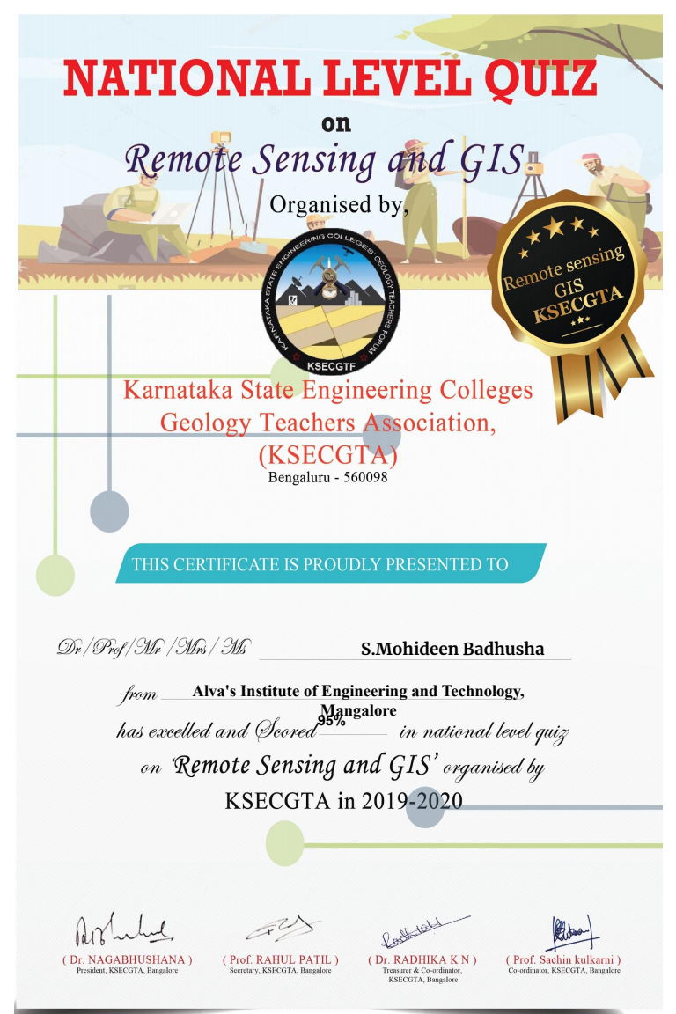

**online challenges**

